|  |  |  |  |  |
| --- | --- | --- | --- | --- |
| I |  | | | H.0.D. : |
| *Issue* No. *:* 01 | *Revision* No. : 00 | |
| SSUED BY : M.R. : | | APPROVED BY : |

*Instrumentation* Monthly check list Section *:* Coalmill

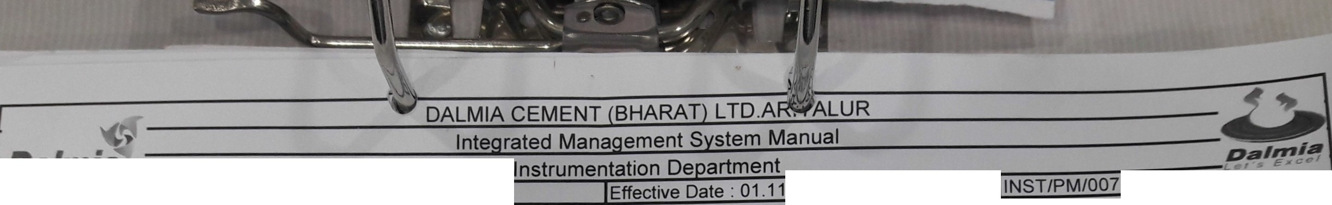

Analyser check List Month:i\J L o ,i

Fine coalBins Gas Analvser Remarb

S.No. *Activities* Status Date of Checkin Done bv

1 *Air* Pressure >4 Ka/ cm OKI N0T 9K

*2* Condensate *Monitor* Paoer OKIN9T 9K ',

' *:-..,.*'B

*3 Flow* of *Flow Monitors* ,40 to 60 L h *OKI* NG::i: QK ...,

4 Comoarina the readina of CO with CCR

*OKI* NOT 9tE

' • ,

5 Comoarin *the* readin of 02 *with* CCR *OKI* N0T OK

.

6 *Panel Cleanliness OKI* NOT Ott ..... J

7 Anv *alarms in Analvser OKI* NO I OK'

*B* Pu *ina Check ina OKI* NOT Ott

Coalmill Baafilter Gas Ana- - - - - -

S.No. *Activities* Status Date of Checkin ·.cone bv Remarks

1 Air Pressure >4 *Kai* cm *OKI* Nef 0tE·

*2* Condensate Monitor Paoer *OKI* Nef et< '-

\

3 Flow of Flow Monitors ,40 to 60 Loh OKI NQ+ 9K -., -;.,,

4 Comoarina *the* readina of CO with CCR OKI NQ+ 9K



5 Comoarina *the readina of* 02 with CCR *OKI* N0f 9K

6 *Panel* Cleanliness *OKI* Nef eK

7 Any *alarms in Anal ser OKI* Nef 9K

*B Purr rina Checkinc OKI* Ne=r= eK

*{)* ,'""·. 1 •